

|  |  |  |  |
| --- | --- | --- | --- |
| **Document Change Record** | | | |
| Version | By | Description | Date |
| 1.0 | Alex | Initial Version | May 13. 2017 |

|  |  |  |
| --- | --- | --- |
| Related Documents | | |
| No | Document Name | Description |
| 1 | Android Mobile App | Development phase |

|  |  |  |
| --- | --- | --- |
| Approval | | |
| No | Approval status | Approver name |
| 1 | NO | Alex |

# **Table of Contents**

Contents

Table of Contents 3

SCOPE OF WORK 4

2.1 Hardware requirements 4

2.2 Software requirements 4

2.3 APK file generation process 4

2.4 Page creation process 4

# PROCESS

## Hardware requirements

* Ram 3 GB or above
* 160GB HDD or above

## Software requirements

* Jdk1.8 or later
* Android SDK
* Windows or Linux
* Android studio
* Git
* NodeJS
* Eclipse IDE
* Apache Ant

## APK file generation process

Step 1: -Install Java

* You can download the latest version of Java JDK from Oracle's Java site − [Java SE Downloads](http://www.oracle.com/technetwork/java/javase/downloads/index.html).
* After you install java, open your environment variable.
* Right-Click on Computer-Properties- Advanced System setting- Environment Variables- System Variables- New

Variable name: JAVA_HOME

Variable value: C:\Program Files\Java\jdk1.8.0_51

* Right-Click on Computer-Properties- Advanced System setting- Environment Variables- System Variables- Path-Edit

C:\Program Files\Java\jdk1.8.0_51\bin ; C:\Program Files\Java\jre1.8.0_51\bin

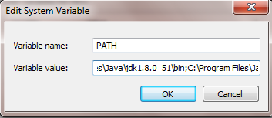

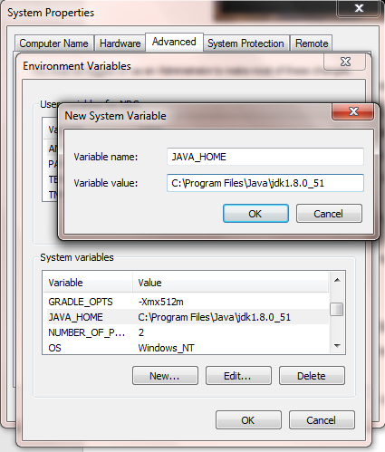

Step 2: -Install Eclipse IDE

* Download the Eclipse IDE from <https://www.eclipse.org/downloads/>
* Open the downloaded file and run the eclipse.exe file, the eclipse screen appears

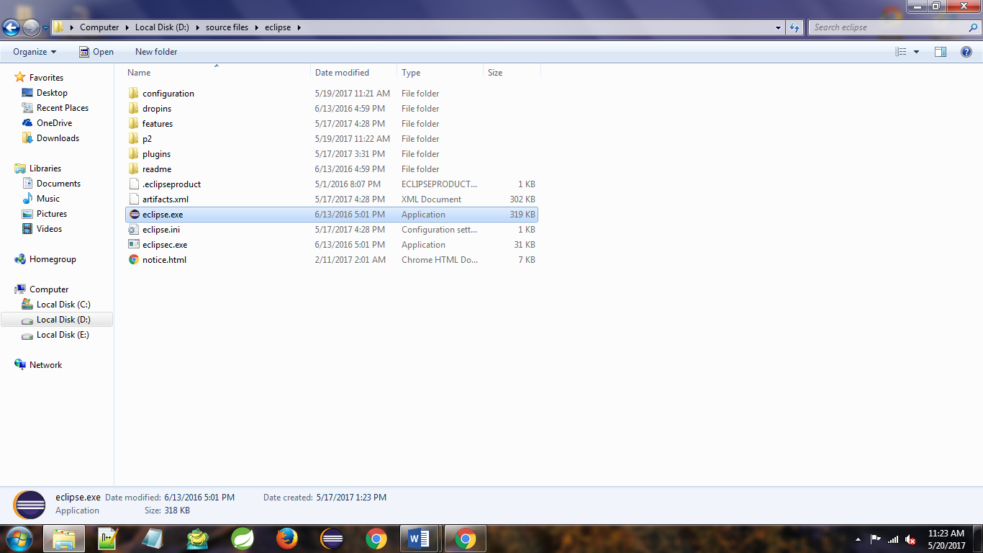

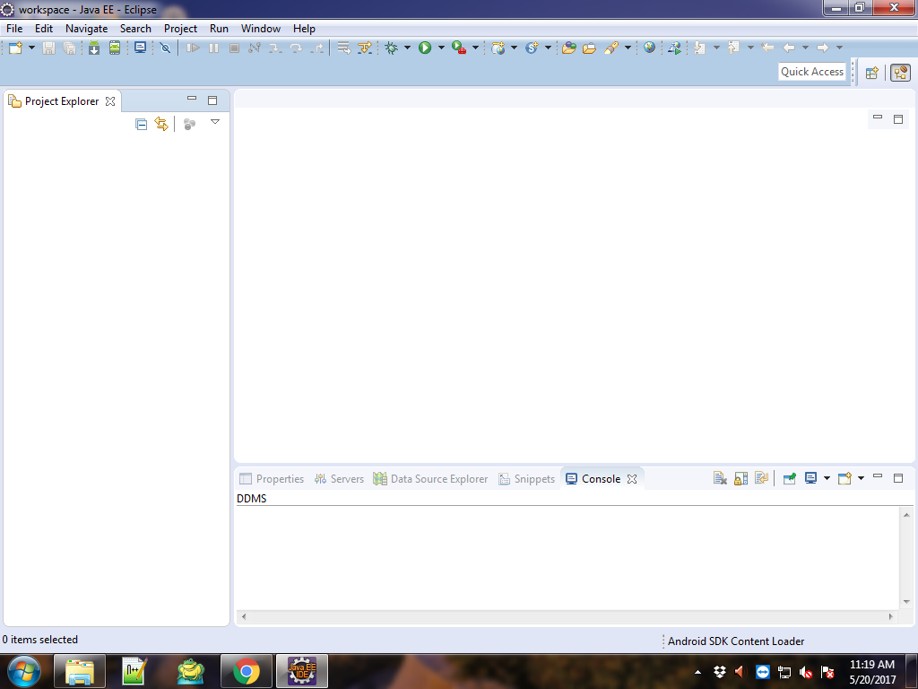

* Next go to help menu and select the “Install New Software”

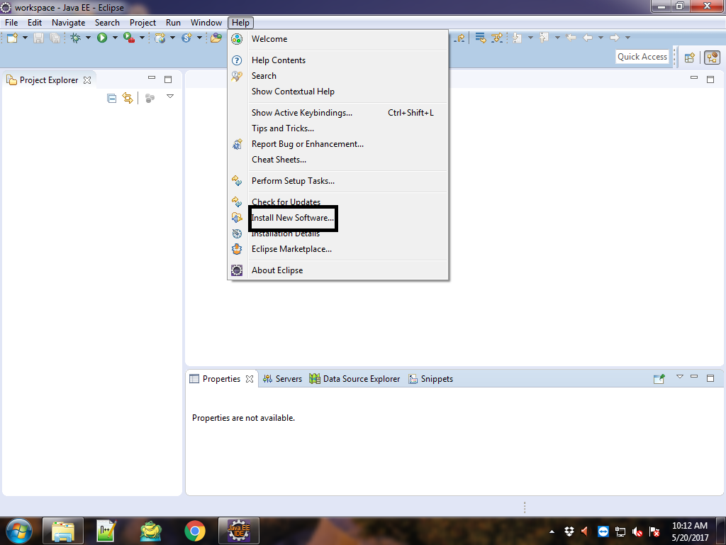

* Click the Add button

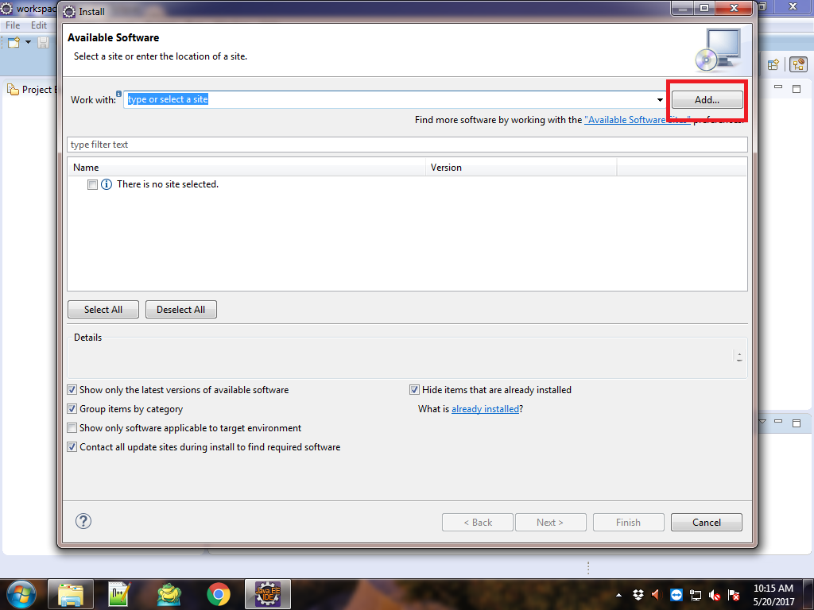

* Add Repository dialog box appears

Name: ADT Plugin

Location: *https://dl-ssl.google.com/android/eclipse/*

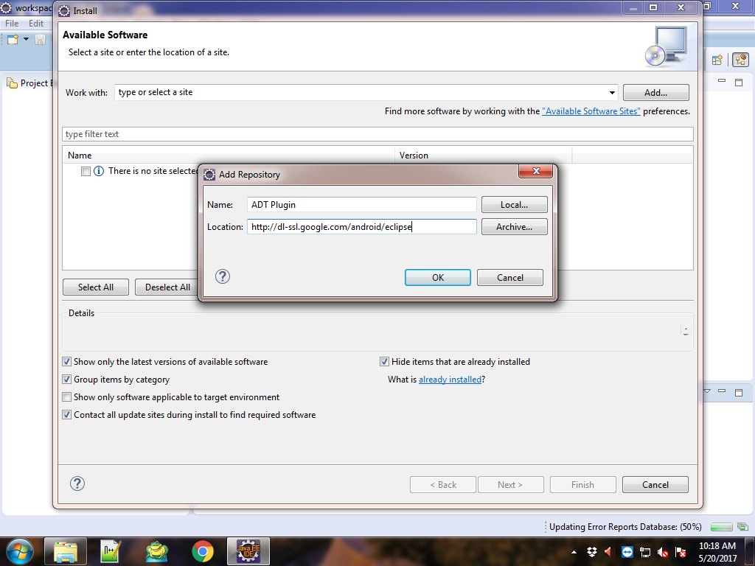

* Click ok, and click Select All button click Next

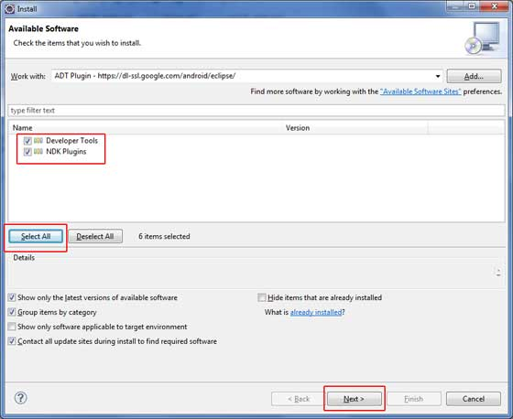

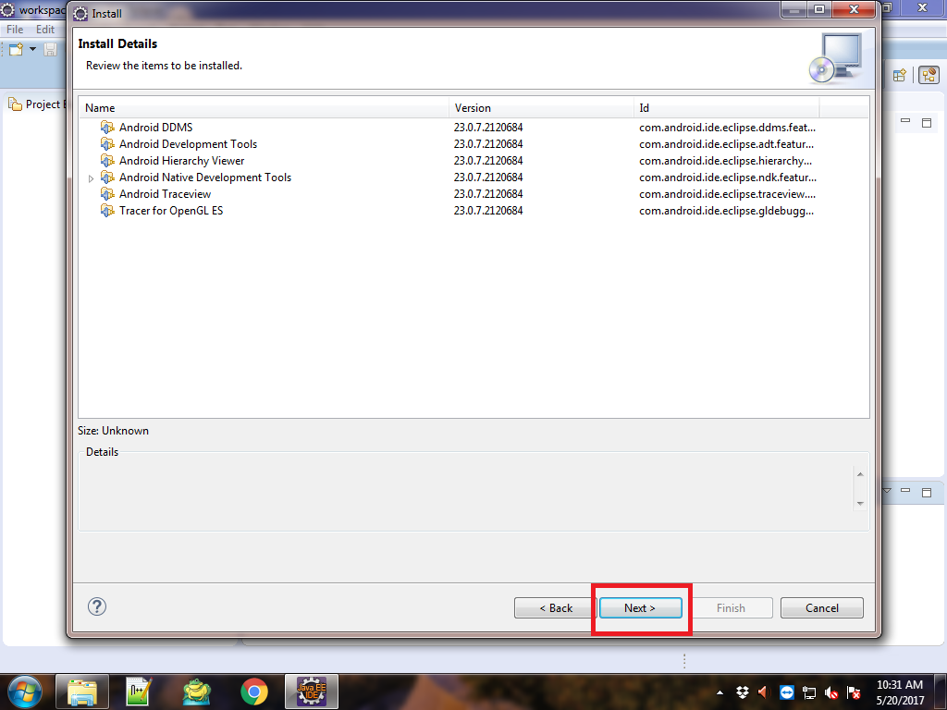

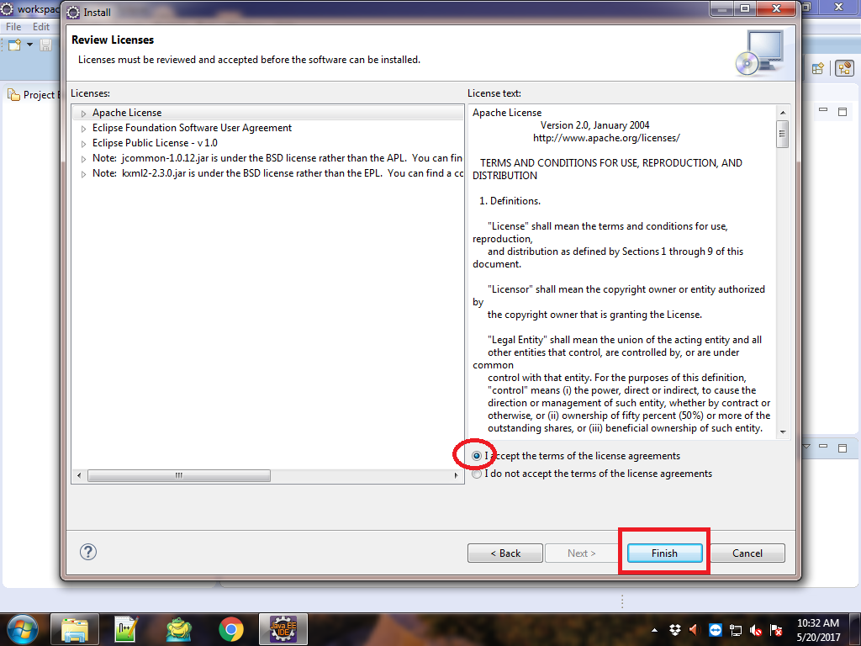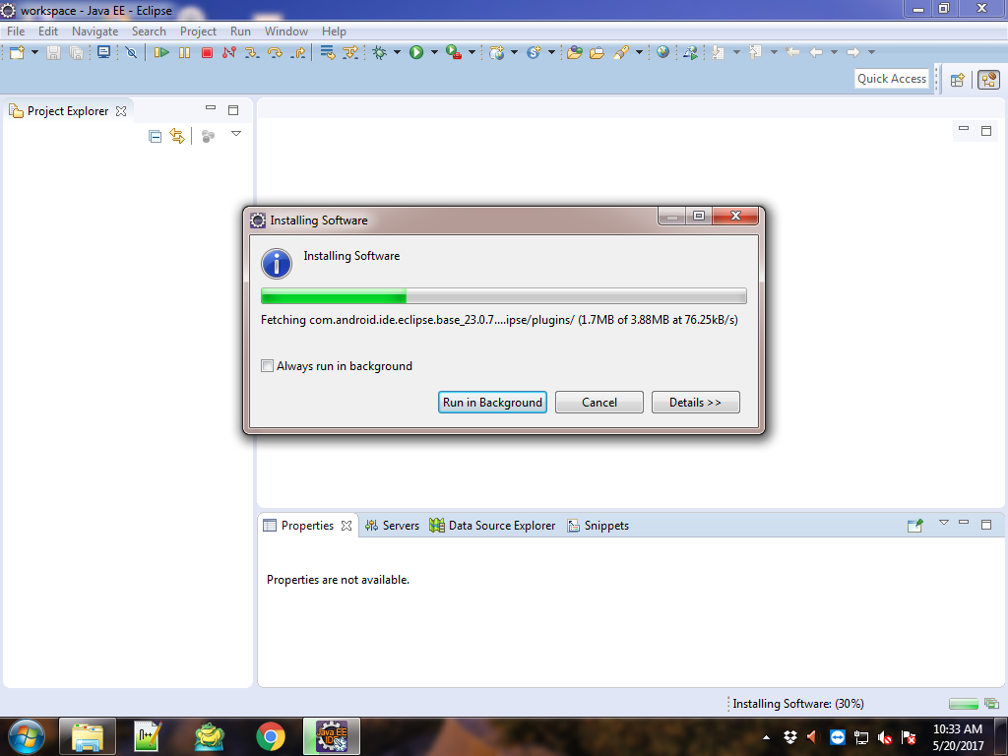

* The installation completes the eclipse restart, and open automatically
* Then the below dialog box appears, to choose the sdk installation path click next button, if you already have sdk choose the existing location click next button

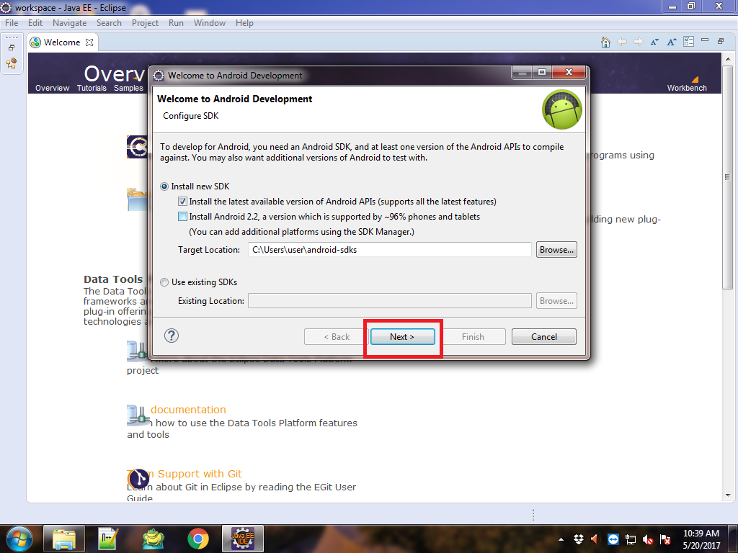

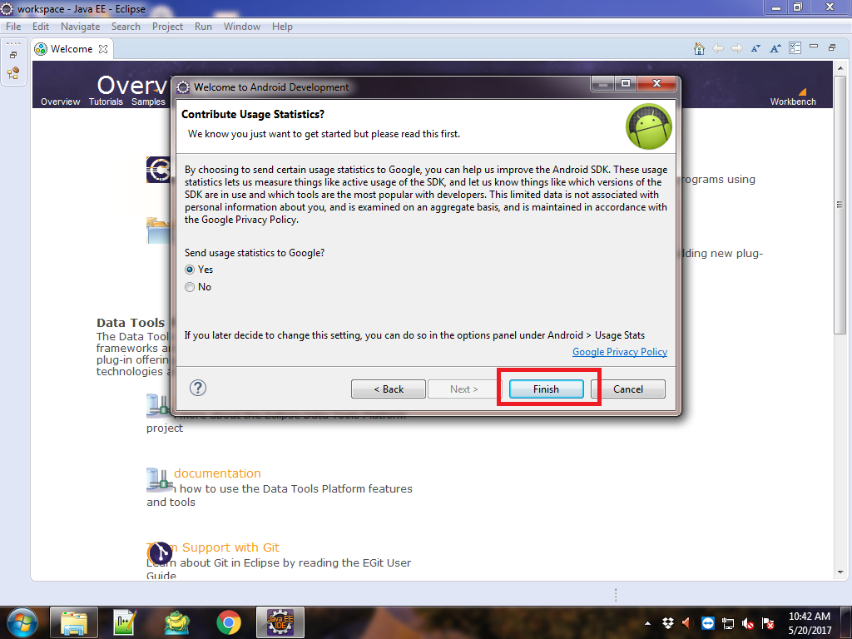

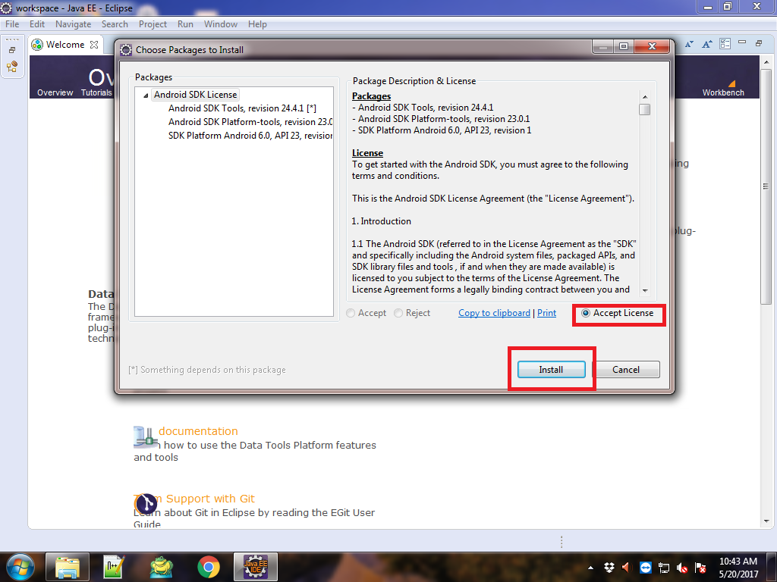

* Click install button the SDKs download in the given sdk path

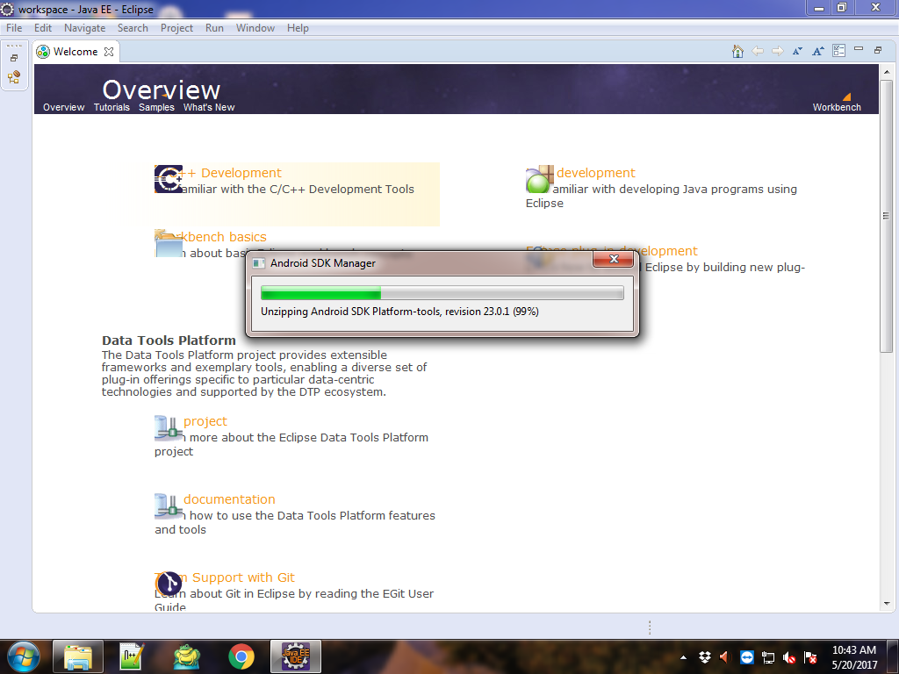

* After complete download, create an android virtual device and add more versions of SDK

## Create Android Virtual Device

* Go window menu – select the Android Virtual Device Manager

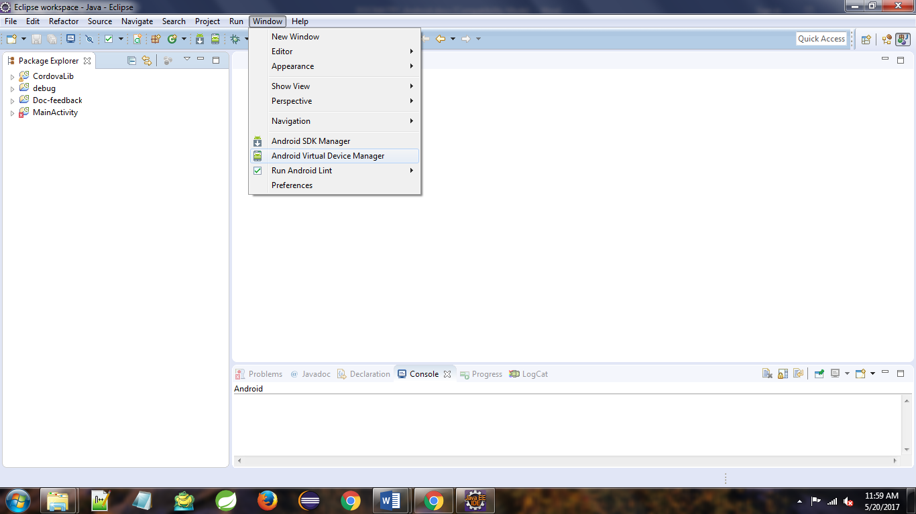

* If some time the Android Virtual Device Manager menu can’t show, in that time go to window menu – select Perspective -Customize Perspective.

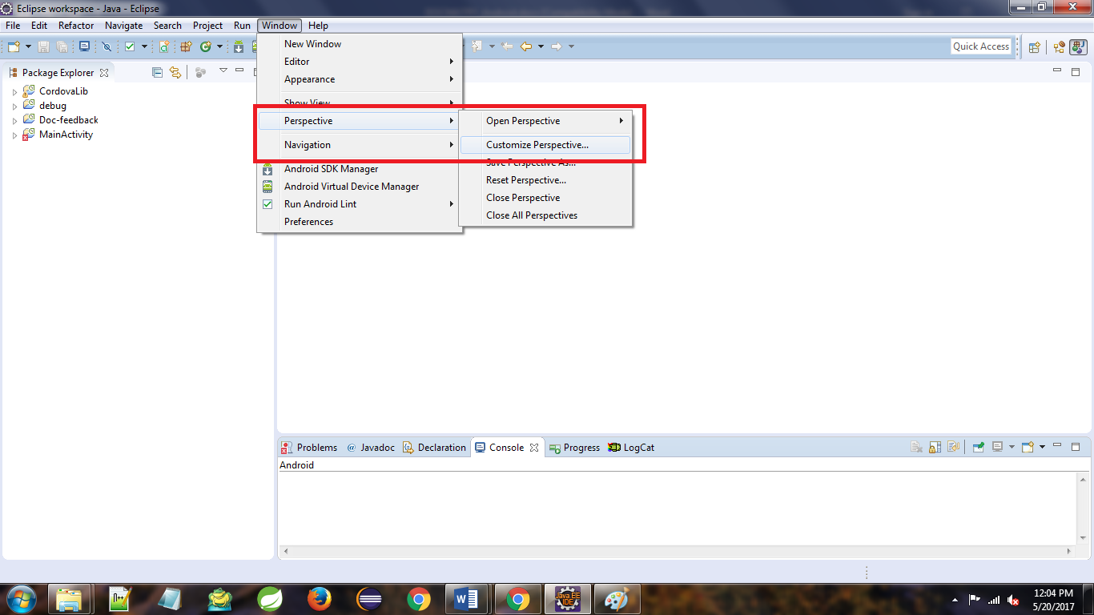

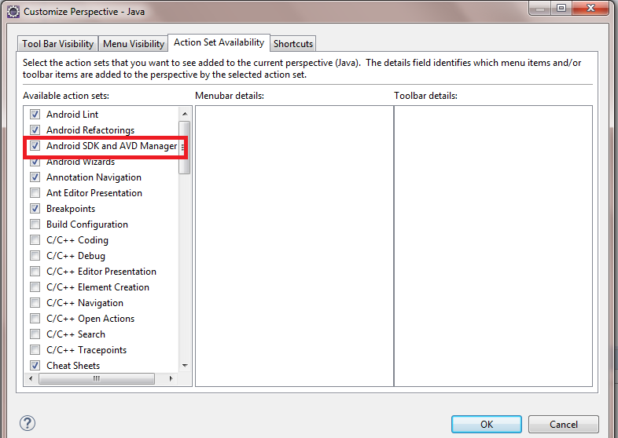

* Go window menu – select the Android Virtual Device Manager

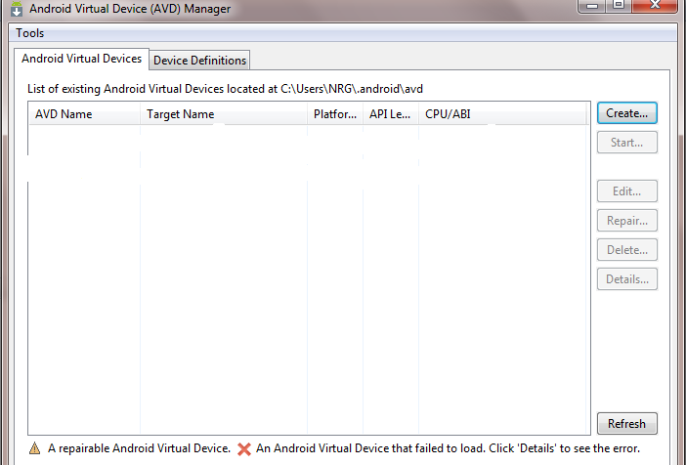

* To click a create button the new window appear

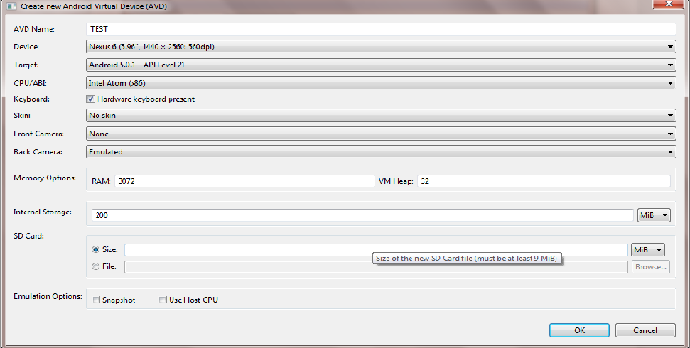

* Configure the device and click ok

If you want more version of android sdk go to window menu select Android SDK Manager, the below dialog box appears,

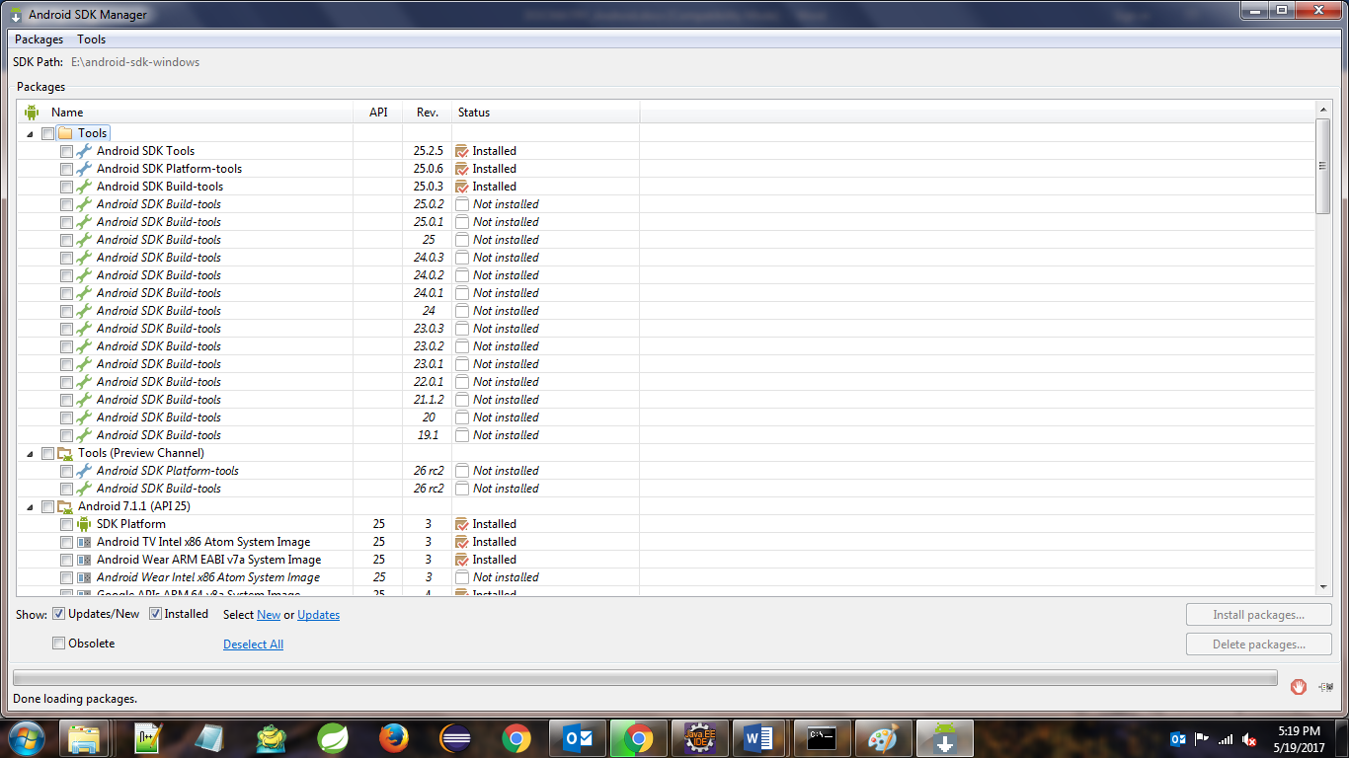

* Select the packages and click the install button, the packages should be download.
* After done the installation set the system variable
* Right-Click on Computer-Properties- Advanced System setting- Environment Variables- System Variables- New

Variable name: ANDROID_HOME

Variable value: your android sdk path

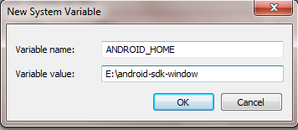

* Right-Click on Computer-Properties- Advanced System setting- Environment Variables- System Variables- Path-Edit

E:\android-sdk-windows\tools; E:\android-sdk-windows\platform-tools;

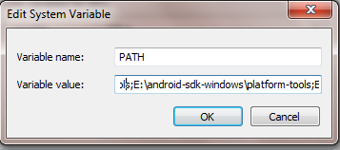

Better you re-start your machine and once you are done set the system variable

**Create Cordova App**

Step 1: - Installing Git

* You can download git [here](http://git-scm.com/downloads)
* After you install git, open your environment variable.
* Right-Click on Computer-Properties- Advanced System setting- Environment Variables- System Variables- Path-Edit and add the git file path.

C:\Program Files\Git\bin; C:\Program Files\Git\cmd

Step 2: - Installing NodeJS

* NodeJS is the platform needed for the Cordova development. Download NodeJS and install.

Step 3: -Installing Cordova

* Open the NodeJS command prompt or windows command prompt
* Give the command in command prompt

**npm -g install cordova**

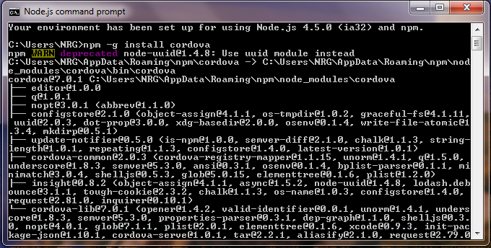

* Open the directory where you want the app to be installed in command prompt.
* Give the command in command prompt

**cordova create CordovaProject com.cordova.coredovaapp CordovaApp**

* **CordovaProject** is the directory name where the app is created.
* **com.cordova.coredovaapp** is the default reverse domain value. You should use your own domain value if possible.
* **CordovaApp** is the title of your app.

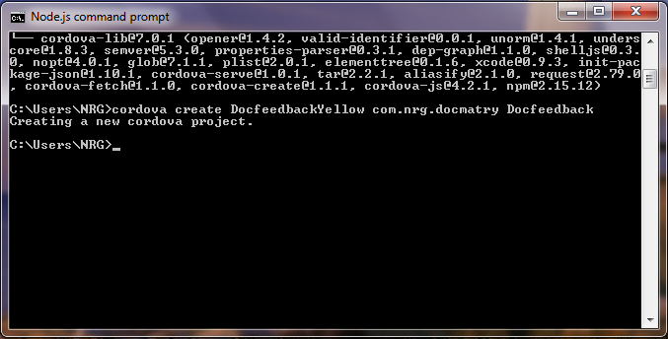

* Cordova project created in the path

Step 6: - Adding Platform

* You need to open your project directory in command prompt

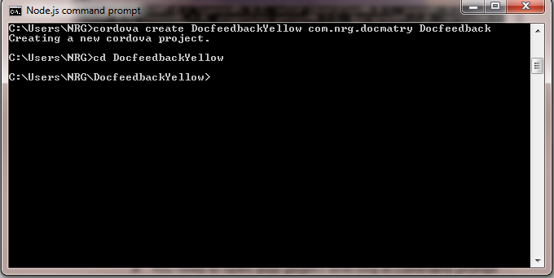

* Give the command in command prompt

**cordova platform add android**

Run the command if got some error like your system cannot find android studio or gradle wrapper, just install the android studio from android official website or download gradle wrapper

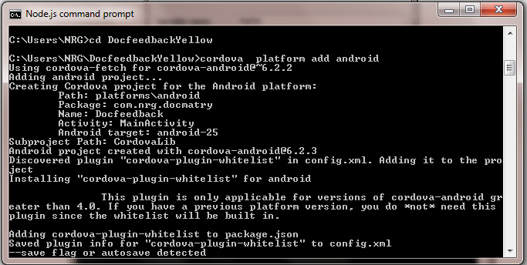

Step 7: - Build the App

* Give the command in command prompt

**cordova build android**

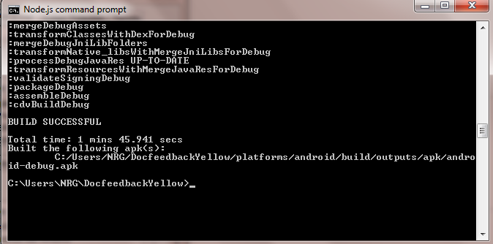

If you got the error liken java vm heap memory error just add the below thinks in system variable

* Right-Click on Computer-Properties- Advanced System setting- Environment Variables- System Variables- New

Variable name: _JAVA_OPTIONS

Variable value: -Xmx512m

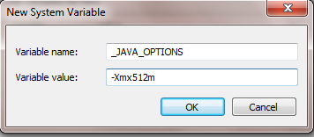

new

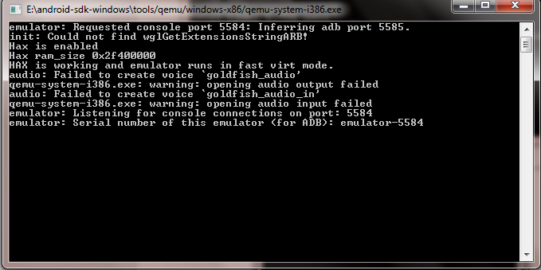

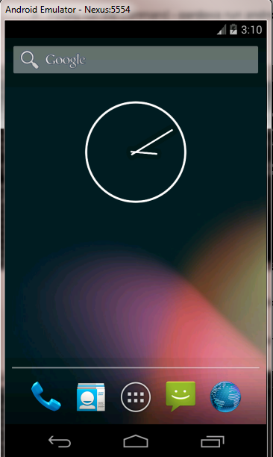

* Finally run the command **- cordova run android**

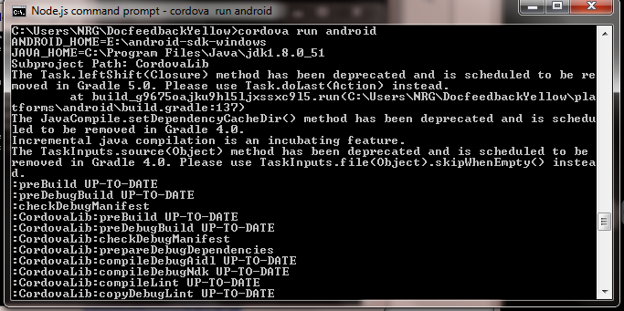

* The android emulator appears like the android mobile, your application also installed the virtual device.
* If the emulator cannot start check the emulator console



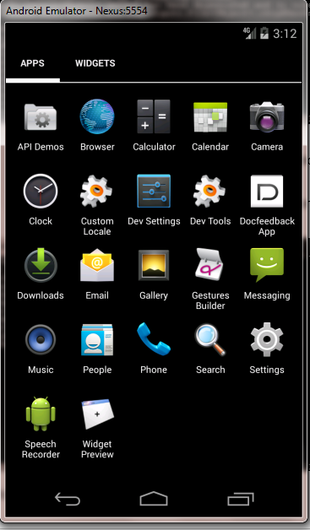

**Get APK file from Eclipse**

Step 1: -Import project

* Open eclipse and Import your cordova project in eclipse from your project directory.
* File – Import – Android -Existing Android code Into Workspace

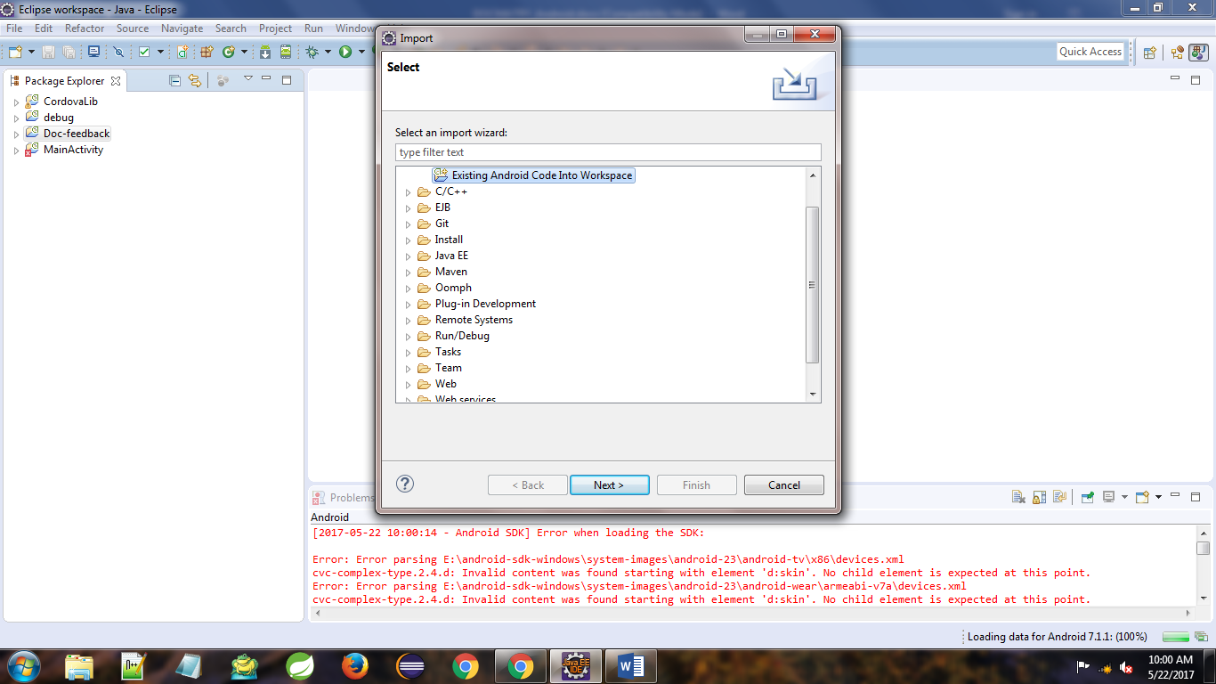

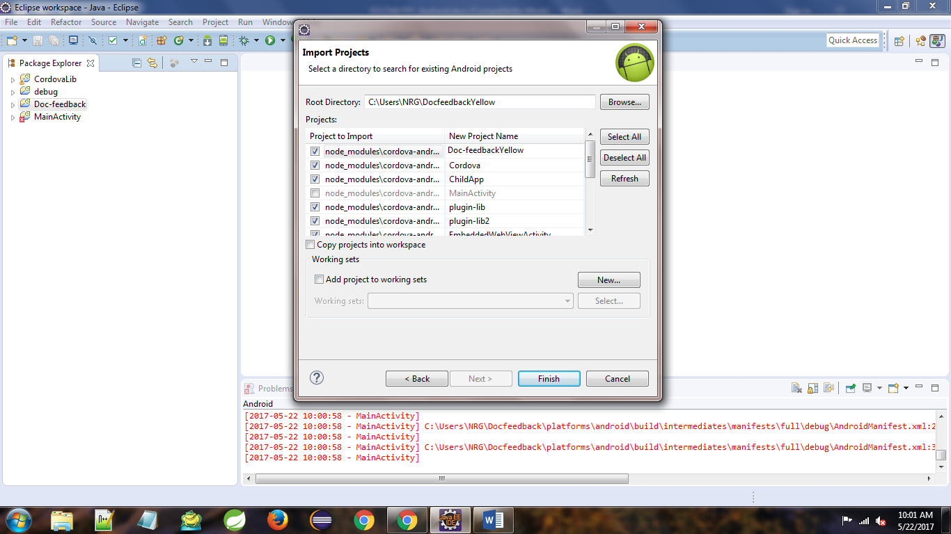

* Import your Cordova project, give the new project name click finish
* Run the project, right click project – Runs As -Android Application.

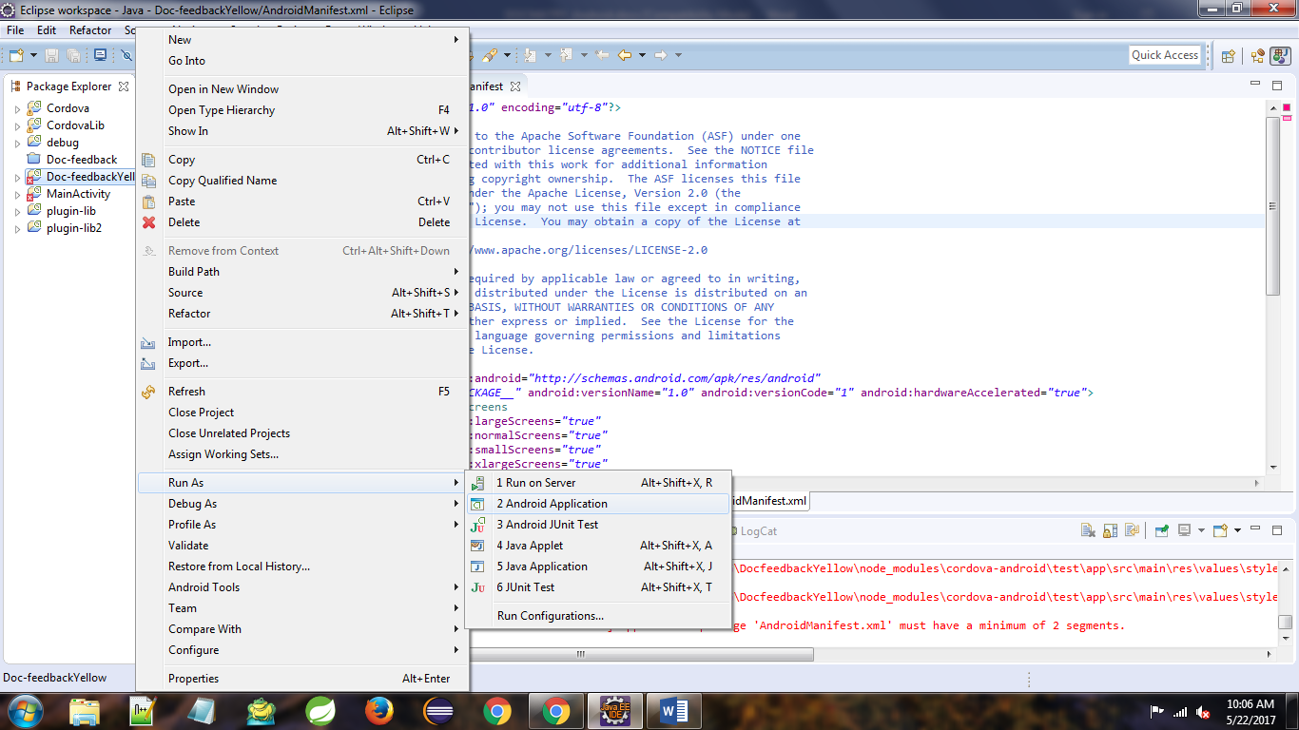

If the project run successfully the android emulator will be start, your application also install in the android virtual device

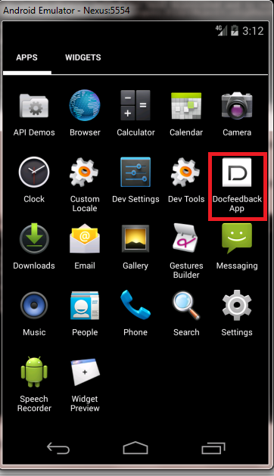

## 

## Get the APK file

## After run the project, File – Export – Export android Application -Click Next-Choose the project-click Next

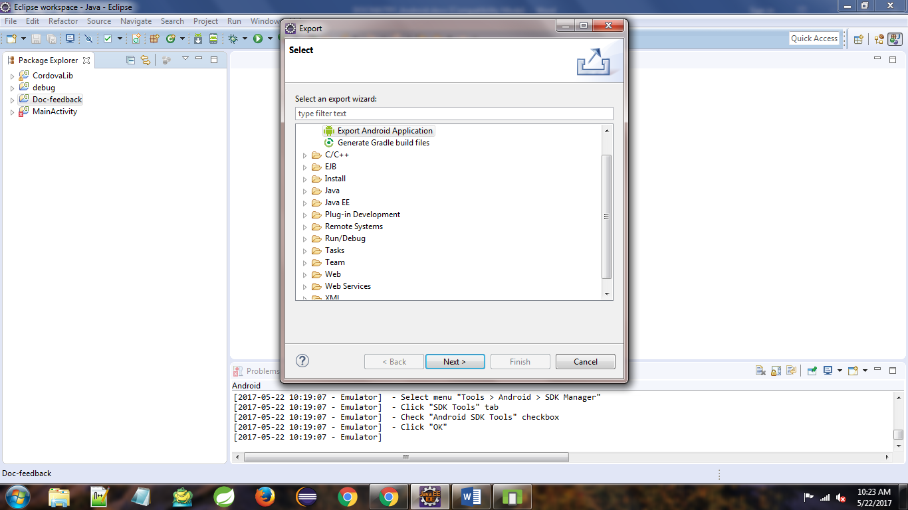

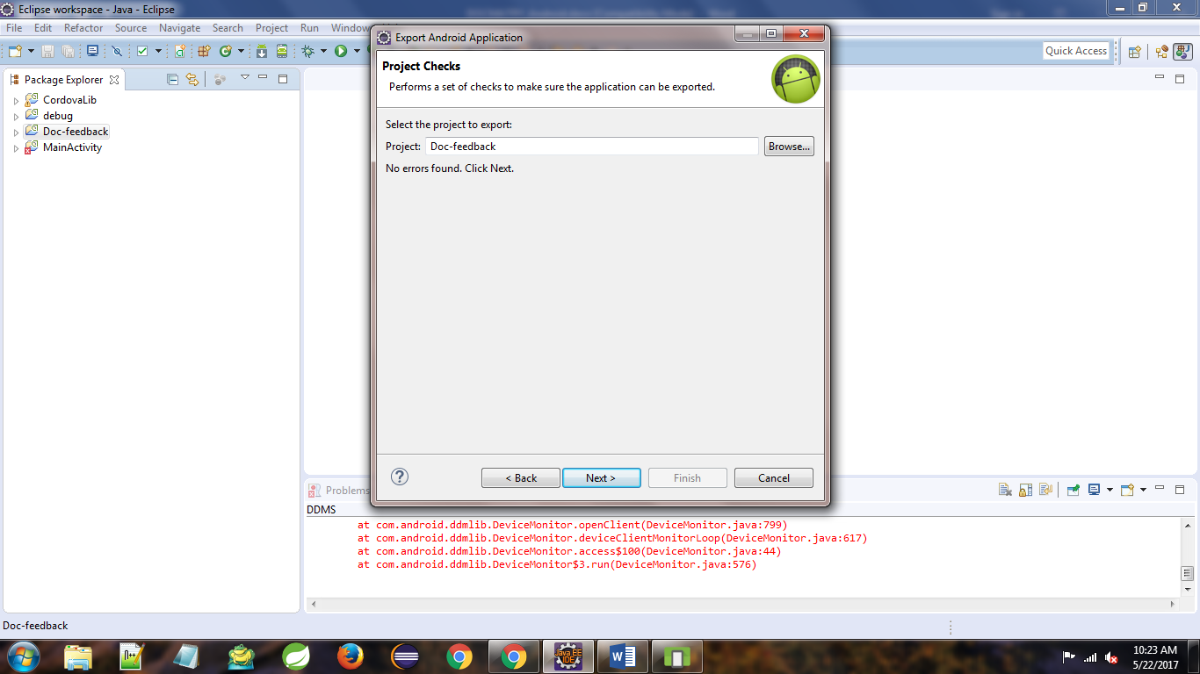

## Click next button next the keystore box appears, If you are using existing one, give the password

## 

If create new give the file location and file name, give password and confirm password and click next, Then key Creation dialog appears, fill the details and click next

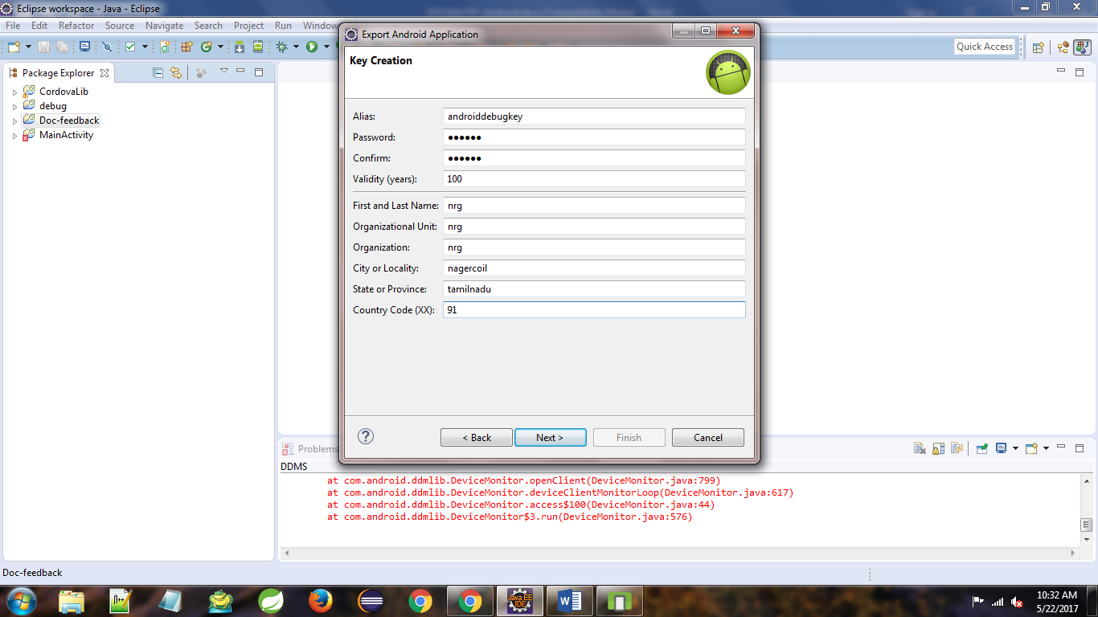

Choose the destination APK file path, and click Finish, the APK file save in to the given file location

